Redesigning the Waterfall Method

David Graves
Colorado State University Global
CSC505
Dr. Steven Evans
January 20, 2025

Standard Software Model Approaches
There are several different ways to approach project structure when considering developing a new piece of software. Each technique or process model has its own strengths and weaknesses, therefore it’s critical that an appropriate model is selected for the project at hand. One of the traditional and oldest models is the “Waterfall Model” which, “suggests a systematic, sequential approach to software development.” (Pressman & Maxim, 2020, page 25) This is a good example of a flow-based method and is ideal for linear process development as its name implies. Other methods of development include structured models like Spiral and V models, iterative ones like Prototype and Evolutionary models and Object-Oriented models (Chandra, 2015, page 7). These all have ideal use cases and can produce positive and negative results equally when used appropriately. I’ll use the remainder of this paper to explore an example of the Waterfall method to understand its weaknesses, offer a modified UML model and share a Python program designed to return key elements of the design in a clean and organized output.
Waterfall Method
As mentioned above, the Waterfall Method has its time and place for usage and because of its nature inherently has shortcomings. One of the places where the method is lacking stands out clearly in the unedited Waterfall Design below in Image 1 with the lack of feedback loops prior to delivery. This method doesn’t account for customer feedback after project initiation and highlights an inherent issue that software developed with this method can’t be fixed or adjusted from initial requirements, even when a customer has difficulty fully explaining those at the beginning of a project.

Image 1 (UML – unedited)
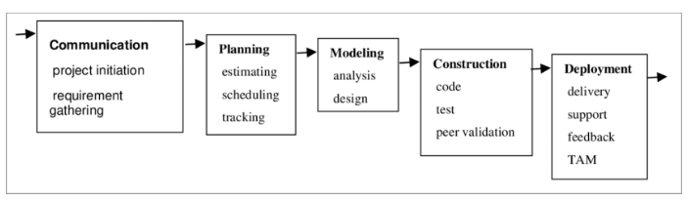
(Adapted from Pressman, 2020, p. 26)
Another challenge in not having frequent check-ins and iterative design capabilities presents itself in customers not knowing what can be created. Guarav Amatya shares that, “many people do not reali(s)e the need for something until it actually exists.” (Amatya, n.d., Paragraph 3) Or in other words, customers may know what they want but may not know what developers have the capability to build. The Waterfall method doesn’t provide developers opportunities to engage customers during design and they are often left to make design judgement calls independently and run the risk of missing opportunities for refinement and redirection prior to delivery. One change to the current flow that can be introduced to combat the challenges mentioned is a simple feedback loop labeled Customer Demo as shown in Image 2 below. By adding this additional step, the customer can now deliver feedback during the development lifecycle and has a greater ‘say’ in what the outcome looks like. Even if no changes are offered during the customer validation stage, that in and of itself provides additional positive feedback prior to delivery that all requirements have been met and that the customer should be happy with the finished product.

Image 2 (UML – edited)
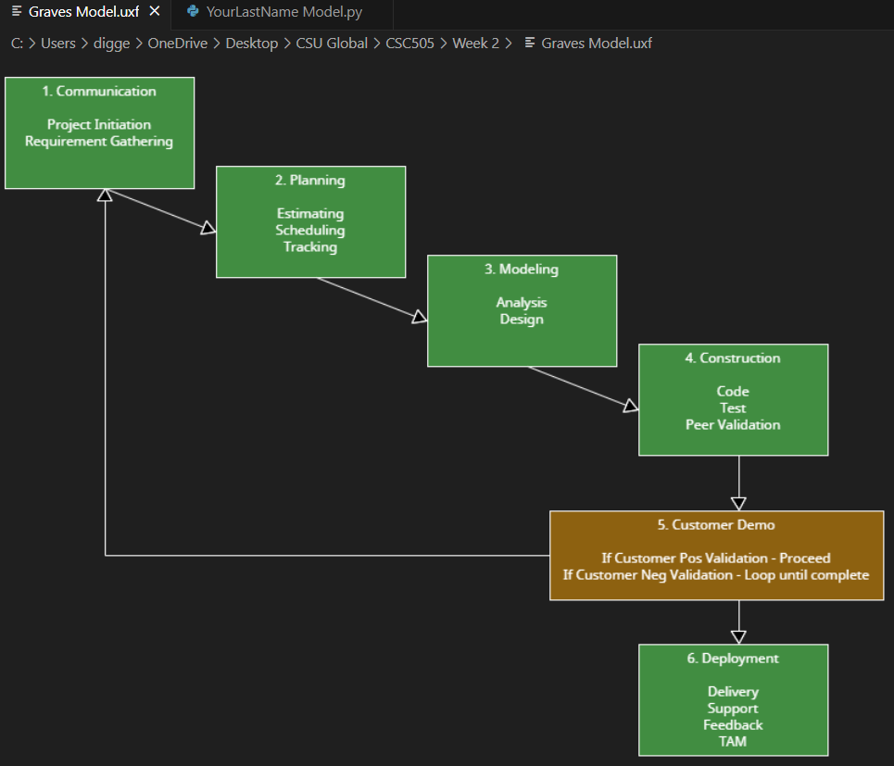
Python Program
The Python coding language provides a good platform to create a program that can mirror a UML design model. I’ve provided a program below shown in Image 3 that prompts a user to input the key elements of the original Waterfall method shared in Image 1. One challenge, or decision point I was unsure about in spinning up this program was how to structurally ask for the information from the user to display later. I chose to simply ask for the items as phases with nested actions. To begin, the program creates a class labeled “YourLastName” and follows with defining how to input the phases and actions based on the value (int) selected by the user.
Image 3 (Python Program)
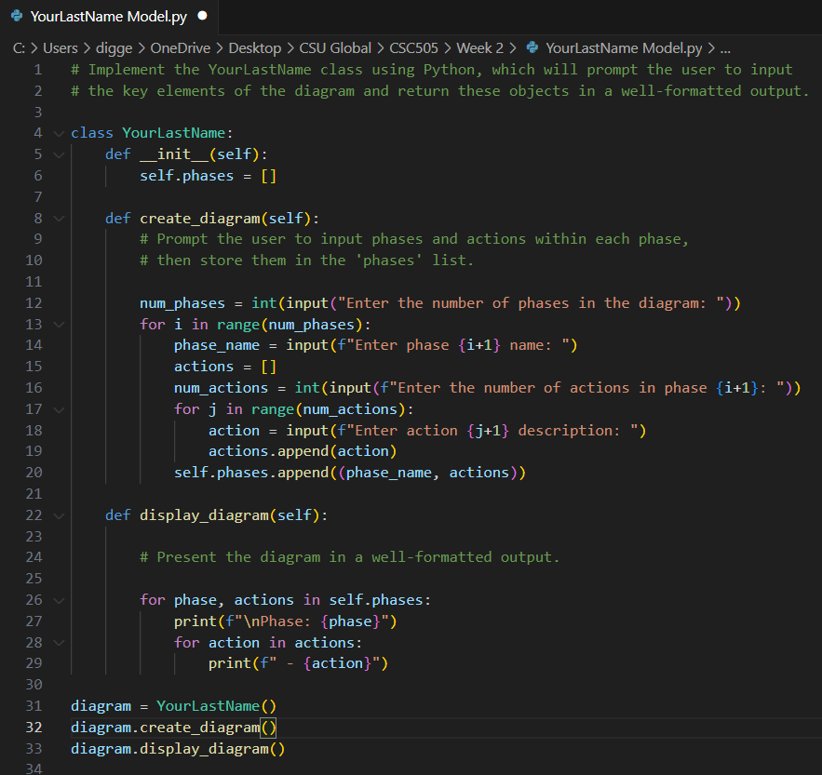
Once the user flows through the input steps I return the entries via print function in an orderly manner as seen in Image 4. The biggest challenge I had during this exercise was jumping back into the language since I typically don’t ‘code’ in my current position. That said, I found it rewarding and discovered that I can build UML diagrams directly in the Visual Studio Code program which is handy.
Image 4 (Terminal Output)
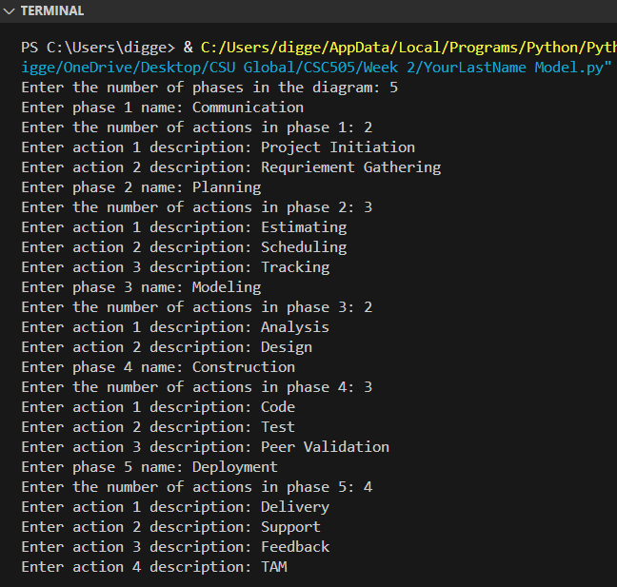
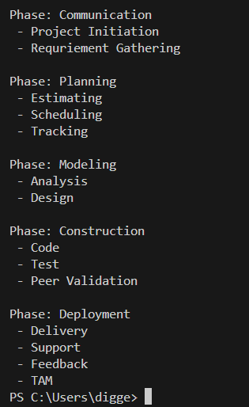
References
Amatya, Guarav (n.d). Zipboard.co. 45+ Key Questions to Ask Your Clients (for Web
Development and Software Agencies)
https://zipboard.co/blog/web-dev/key-questions-to-ask-clients/#:~:text=Remember%2C%20most%20customers%20know%20what,something%20until%20it%20actually%20exists.
Chandra, V. (2015). Comparison between various software development
methodologies. International Journal of Computer Applications, 131(9), 7-10.
Pressman, R. S., & Maxim, B. R. (2020). Software Engineering: A Practitioner’s
Approach. Retrieved from: https://platform.virdocs.com/read/1490446/58/#/4/4
Approach Retrieved from: https://platform.virdocs.com/read/1490446/59/#/4/2

